**PROJECT SCOPE**

The complete project scope is defined on the project understanding documents received.

**PURPOSE**

The purpose of this document is to present a detailed description of the Tourism management System. It will explain the purpose and features of the system, the interfaces of the system, what the system will do, the constraints under which it must operate and how the system will react to external stimuli. This document is intended for both the stakeholders and the developers of the system.

**PROJECT SCOPE**

The Tourism Management System project is an implementation of a managing Tourism website which helps the customers to search the availability of various tourist places and Commercials of various packages in particular places, along with the different packages available with the reservations. This project also covers various features like online registration of the users, modifying the details of the website by the management staff or administrator of the website, by adding, deleting or modifying the customer details or packages information. In general, this website would be designed to perform like any other Tourist management website available online.

**PROJECT UNDERSTANDING**

1. **Login** (End User and Partners will have separate Login Page window. In the Customer Portal However, we will have the Link for opening the Partner Portal by pressing of My Partner Tab.
2. **End User Login-End user Login can be created either of the below –Thru Web and Mobile App. admin Approval Not Required**

* Facebook
* Google
* Instagram
* LinkedIn
* General Profile (Filling Form Details)-forms Fields-Name, Email id, Mobile No., Title (MR/MRS/MS), these all are mandatory Fields
* Optional Field, Address, Country and State with Pin code, Hobbies -Multiple Selection (We will input some categories, and user can also input his hobby if it’s not available in the list)

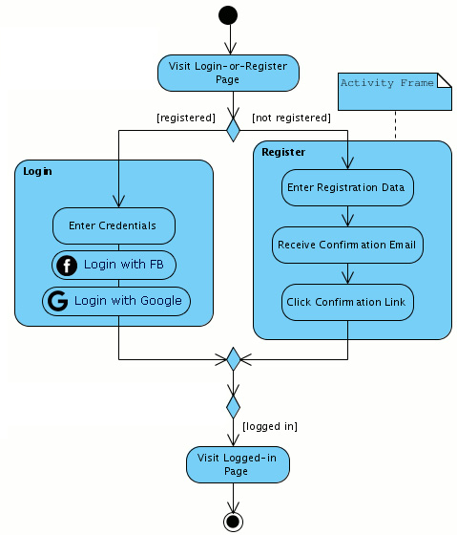

If a User comes on the Site for more than 3-4 Minutes than a Pop-up window to appear to Prompt him for creating Login.

Membership (Nomenclature Gold or Exclusive or suggest name) to be given –

**Invite a Friend Tab- 2 Options (Pls Confirm for the same)-**

**1st Option-** End user will enter details of referral, Name, Mobile No, and Email id, Multiple friends can be selected, Mailer and SMS (if required) will go to all these ids and Mobile no. which will have Link to Create login. at the backend we will keep the details of whom they are referred by and upon successful registration, Voucher of Rs.500 will get credited. (Please Confirm can only 1 person can be referred or Multiple and if Multiple, than always Rs.500 Voucher will be Credited or not)

**2nd Option-** End User can generate link which will have his referral code, which he can send to his friends and they can Open that Link and Create Account, Upon Successful upon successful registration,

Voucher of Rs.500 will get credited. (Please Confirm can only 1 person can be refer or Multiple and if Multiple, than always Rs.500 Voucher will be Credited or not)

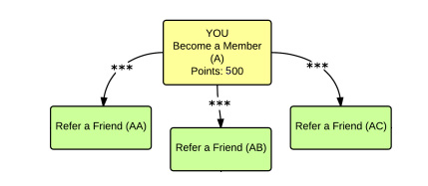

**Blog & Experience-** User can Upload Blog in Blog Button (Text and Pictures) and other Users can comment and **like those.**

**Home page or User home Page after Login- For B to C**

**It will have below Buttons which will open a separate Page-**

* **Destination-** Multiple ways search -By Continent, By Country and further Major Cities. Once Country or City is Selected than all Major Packages will get displayed, on clicking details of the Package will get displayed, from here he/she can either book the Package or ENQUIRE on the same by filling below details-Name, Contact No., Mobile No., Email id or For Registered User this info will be automatically captured.
* **Collection-** Also a type of Category for searching Holidays based on Theme, Solo Trip, Bike Trip, Romantic Holidays, Women only
* **Activities-** Customized Holidays with Various Categorization as Adventure, Cultural, Night Life, Group Booking with details to be obtained at Booking and Inclusion, exclusion and material to be Carried and Map route for reaching that destination.
* **Deals-** Exclusive for Members Only. What has to be shown here?
* **Brew club-** It’s a Kind of Forum where travels ideas are shared, categorized into Domestic and International and further Categorized into Romantic, Heritage, Road Trip, Women Only Travel by search option. Shares can be in the form of Pictures, write up, video as Link.

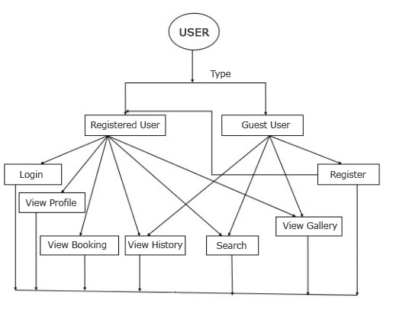

When a Customer Buys a Package, than Instantly Confirmation will be sent on mail and WhatsApp.

Testimonials-This is will be Posted by Admin and will be available on the Main Web page on Customers based on his Experience with Holiday Packages, Customer can write text, Post Pics of his experience. Please Confirm whether Registered User can Also Post or admin will Post Only.

Reviews-Reviews to be made By Customer on his Experiences with Packages and Travel and Services. Whether Admin approval Required for Posting. Pls Confirm?

1. **Partner Login-** Through Web - Admin Approval Required.

**2 Step Process-**

1st-Name, Mobile No., Email id (OTP verification if required)

2nd Step-Business details-

Company Name, Contact Person, Contact no, Address with Pin code, Address Proof (Scan Copy upload) Mandatory Field, Upload Logo,

GST details, PAN No., Web site Optional Field,

Partners will see their Sales and will Upload their Package along with Pictures and Videos, but will be available Post Approval of Admin.

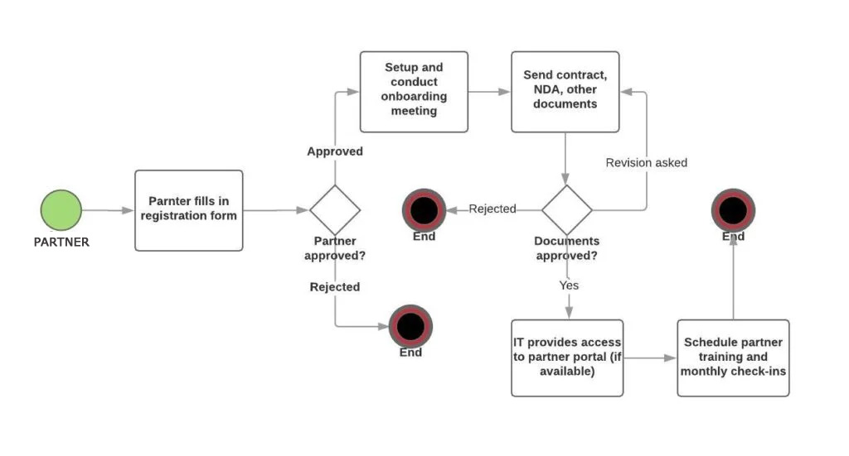

**E -Store-**

Listing of items, Customers can Purchase, pls Clarify only Registered user or Guest User can also Purchase. Multiple items to be added in Cart and all info related to Billing and Dispatch address with Pin code, and Mobile No, and Email id to be taken and linked with payment gateway.

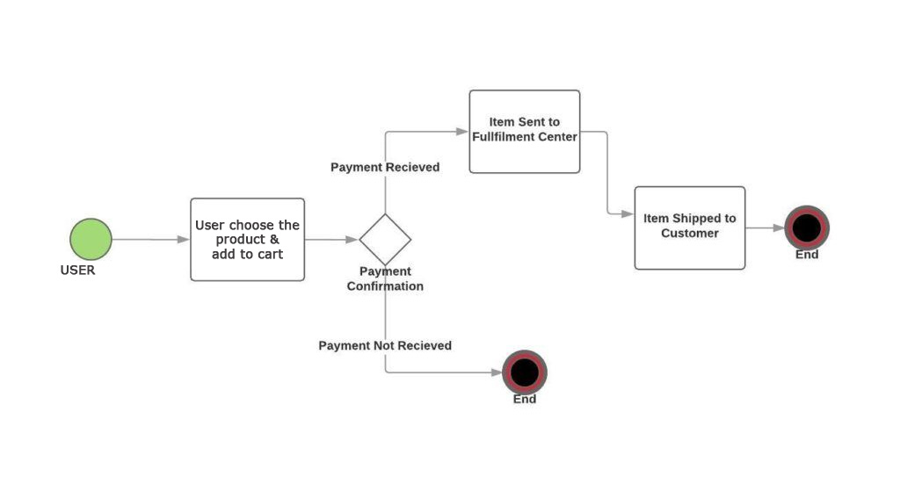

**Footer Links: -**

* Home
* About Us
* What We Are
* Our Blog
* FAQ
* Terms & Conditions
* Privacy Policy
* Cancellation Policy
* Social Media Links (FB, Twitter, Instagram, LinkedIn)

**Note: - For Above all Conten t& Images has to be provided from Client End.**

**REQUIREMENTS (from client)**

* Clarity on whether Aggregator will also be selling his packages or only the agents.
* Whether Agent will work on App and Web Both or Web Only.
* Guest User is required if Customer doesn’t Create Account or Customer has to Mandatory Create his Account and can proceed Further to Purchase Packages.
* OTP Confirmation on mail and Mobile is required for Partner during registration? If required than Mail and SMS gateway Server to be provided and Integrated.
* For Exclusive Membership, the Criteria or any Commercial yearly to be Charged?

By default, the Currency will be Automatically Picked up as per the Location, the Customer has Logined into the website, however he has the option to change the Currency manually.

**Customer Management Function-A customer Enquiring for a Particular Package and while doing so will leave his Info (Name, Contact No. and Email) For Registered User this Information will be Automatically captured and same will be available in the Admin Panel and also details will be sent on the Admin Registered Mail id and on WhatsApp.**

**Does we require a Complete Enquiry Management and Allocation System and CRM. Please Clarify on the same?**

**Similar Tours and Packages -When a Customer Select a Particular Holiday Package than a window will show the details of User who have Already bought this Package.**

**Influencer Reach out Page-**

**News Letter Subscription-It will Appear on Every page on Footer.**

**Blog-A Seprate Tab naming “Blog” will appear on Home page in footer and in Registered User home page also.Registered User can Post the Content in the Blog and view the Blogs of other also , However unregistered user can view the Blog but cant Post , However we can have the registration Process of User Initiated from There itself**

**Gift cards-Gift Card Denomination is clear, but where it will be used ,and will it be used when Buying Packages ..and how those Gift Card value will be used .wether in the Referral Programme GiftCards are to be Credited?**

**Women Affliliate Programme-A separte Programme for Women Entrepreneurs , a seprate tab will be given which when clicked a page to capture details , Name and Contact details ..and those details will be available on Admin Panel and sent on Email and Whats App of Admin.IF they have their Own Website than the same will be Integarted and our Products and Holiday Packages can be sold , if they don’t have than a Basic website will be Provided on extra Commercials.**

**Self Drive-Self Drive Vehicle Package within India and International will be Available ..in a separate tab for Users , subdivided Into Domestic and International.customer will book those Packages and Pay accordingly .For International self Drive However , Credit Card Linking for Payment will be Mandatory.**

**Caravan Rental- Seaparte tab for this will be available on Home Page , Subdivided into Domestic and International ..These are Both , Self Drive and Chauffer Driven a, accordingly User will have Package Choices , and Commercials in case of Domestic will be as per No. of Days apart from that Initial Deposit will also be there .For International Credit Card Linking for Payment will be Mandatory.**

**Booking of Caravan and Self Drive , from and To date will be Selected ,No. of Packages , Price ,Amount will come , the same needs to selected ,than Book Now button will Appear and the same will be added to Cart , at the time of Final CheckOut the Payment gateway will get opened to make Payment.**

**If a Package is in a range of No. of people , For Example , 2-6 people , than if its booked for 2 , 3 , 4 , 5 or 6 Price will remain same.**

**Third Party Website or Link Integartion-A Link or API integration so that a New page open which will be Website of Third Party.**

**TECHNOLOGY -**